SOFTWARE TESTING- Software testing is the process of evaluating a software application to ensure it functions correctly, meets requirements, and is free of defects. It involves executing the software under controlled conditions to identify any bugs, errors, or missing requirements.
MANUAL TESTING- Testers execute test cases manually without automation tools.
TRICENTIS TOSCA-Tosca is a model based tested automation tool, it is a continuous testing platform designed to automate end-to-end testing for software applications. It supports a wide range of technologies, including web, mobile, API, and desktop applications, making it a versatile solution for enterprises looking to improve software quality and speed up release cycles.
What is Scenario?
A scenario in software testing is a high-level description of how a user might interact with the application to achieve a specific goal. It outlines real-world usage situations and helps testers verify whether the software behaves correctly under different conditions.
Example of a Test Scenario
Scenario: Verify the login functionality of an e-commerce website.
- Steps:
  - Open the website.
  - Navigate to the login page.
  - Enter valid credentials.
  - Click the "Login" button.
  - Verify that the user is redirected to the homepage
COMMON USES OF TOSCA-
- Regression testing
- API testing
- UI testing
- SAP testing
- DB (Data base) testing
FRAMEWORK OF TOSCA-
- Reusability Framework - The Reusability Framework in Tosca is designed to improve test efficiency by creating modular and reusable test assets. This approach reduces duplication, simplifies maintenance, and enhances scalability in test automation.

- Keyword Driven Framework -Uses pre-defined keywords (actions) to create test steps. Enables testers to build test cases without coding. Increases test case reusability across different scenarios.

- Tosca Distributed Execution (DEX) Framework-Runs tests in parallel across multiple machines for faster execution. Optimizes resource utilization in large-scale environments. Supports execution on cloud-based infrastructure.

- Tosca Test Data Management (TDM) Framework-Manages test data using synthetic data generation. Ensures data consistency and compliance (GDPR, HIPAA).Reduces dependency on production data.

- Scalability Framework- The Scalability Framework in Tosca ensures that test automation can handle increasing workloads, large datasets, and complex environments efficiently. It helps in maintaining performance, reusability, and parallel execution as test suites grow.

INSTALLATION OF TRICENTIS TOSCA-
Please refer detailed installations steps in File named as (Tosca Installation)

🔹 Prerequisites for Tosca Installation

System Requirements
✅ Operating System: Windows 10/11, Windows Server 2016/2019/2022
✅ Processor: Intel i5/i7 or AMD equivalent
✅ RAM: Minimum 8 GB (Recommended: 16 GB or more)
✅ Disk Space: At least 10 GB free
✅ Database (Optional): Microsoft SQL Server (for Tosca Test Repository)
✅ .NET Framework: Version 4.8 or later
✅ Browser Support: Chrome, Edge, Firefox
Step 1: Download Tosca Installation Package
- Download the Tosca Installer .exe file
Step 2: Run the Installer
- Right-click on the Tosca .exe file and select Run as Administrator
- Choose Standard Installation Default (recommended for most users)
- Accept the license agreement and click Next
Step 3: Complete Installation
- Click Install and wait for the installation to complete
- Once finished, click Finish

Step 4: Verify Installation
- Open Tosca Commander
- Check if default workspace loads properly
- Run a sample test case to verify execution
Tosca is now installed and ready to use! ……..

CREATE WORKSPACE:
The work environment in Tricentis Tosca is a so-called workspace. This workspace is made up of various sections in which you plan, create, and execute your tests.
You can create two different kinds of workspaces: single-user or multi-user.

Work in single-user environments-
- Create single-user workspaces for environments where only one person needs access to data.
Work in multi-user environments-
- Create workspaces for multi-user environments where several people need access to the same data.
In this case, you have several workspaces on several machines; one workspace per machine. All workspaces are connected to one common repository, which is stored in a database.
TYPES OF COMMON REPOSITORIES-
- SQ LITE
- ORACLE
- MS SQL SERVER
- DB2
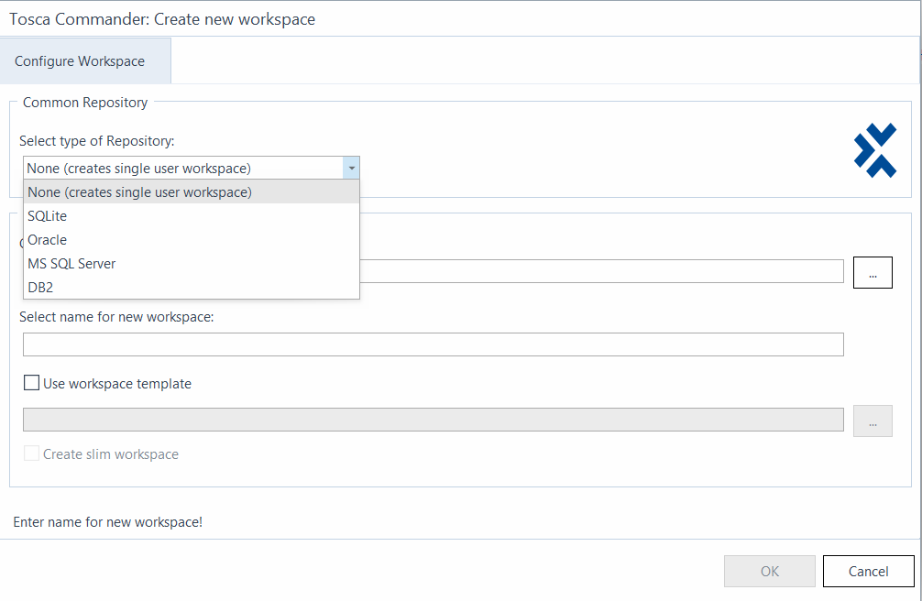
STEPS FOR WORKSPACE CREATION-
- Click on “create as new” button where you get the below screen.
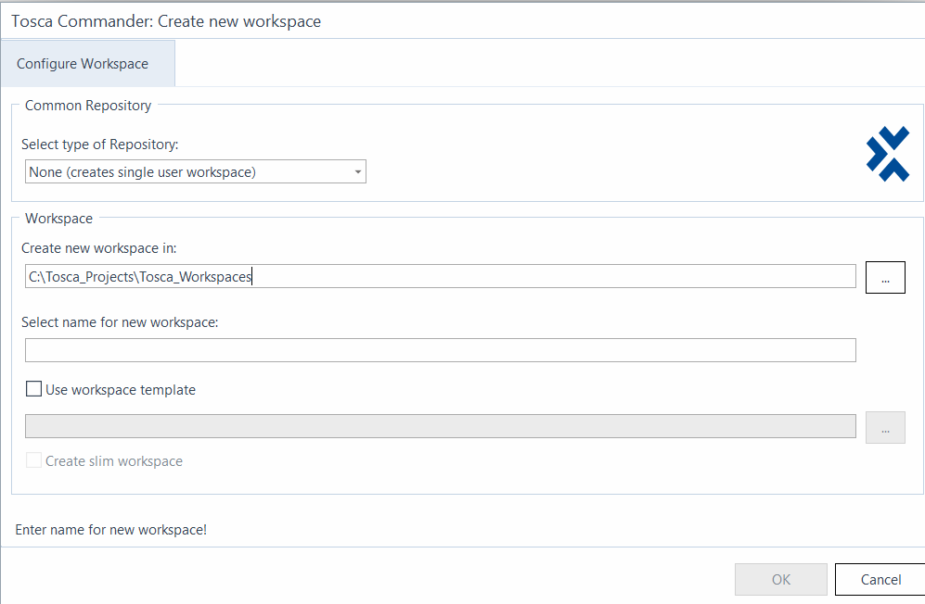

- Select the type of repository you want (single user /multiuser)
- Creating new workspace name will get by default after selecting type of repository you want (single or multi)
- Select the new name for workspace
- Check the box- use workspace template
- Click on ok.
- Workspace looks like the below
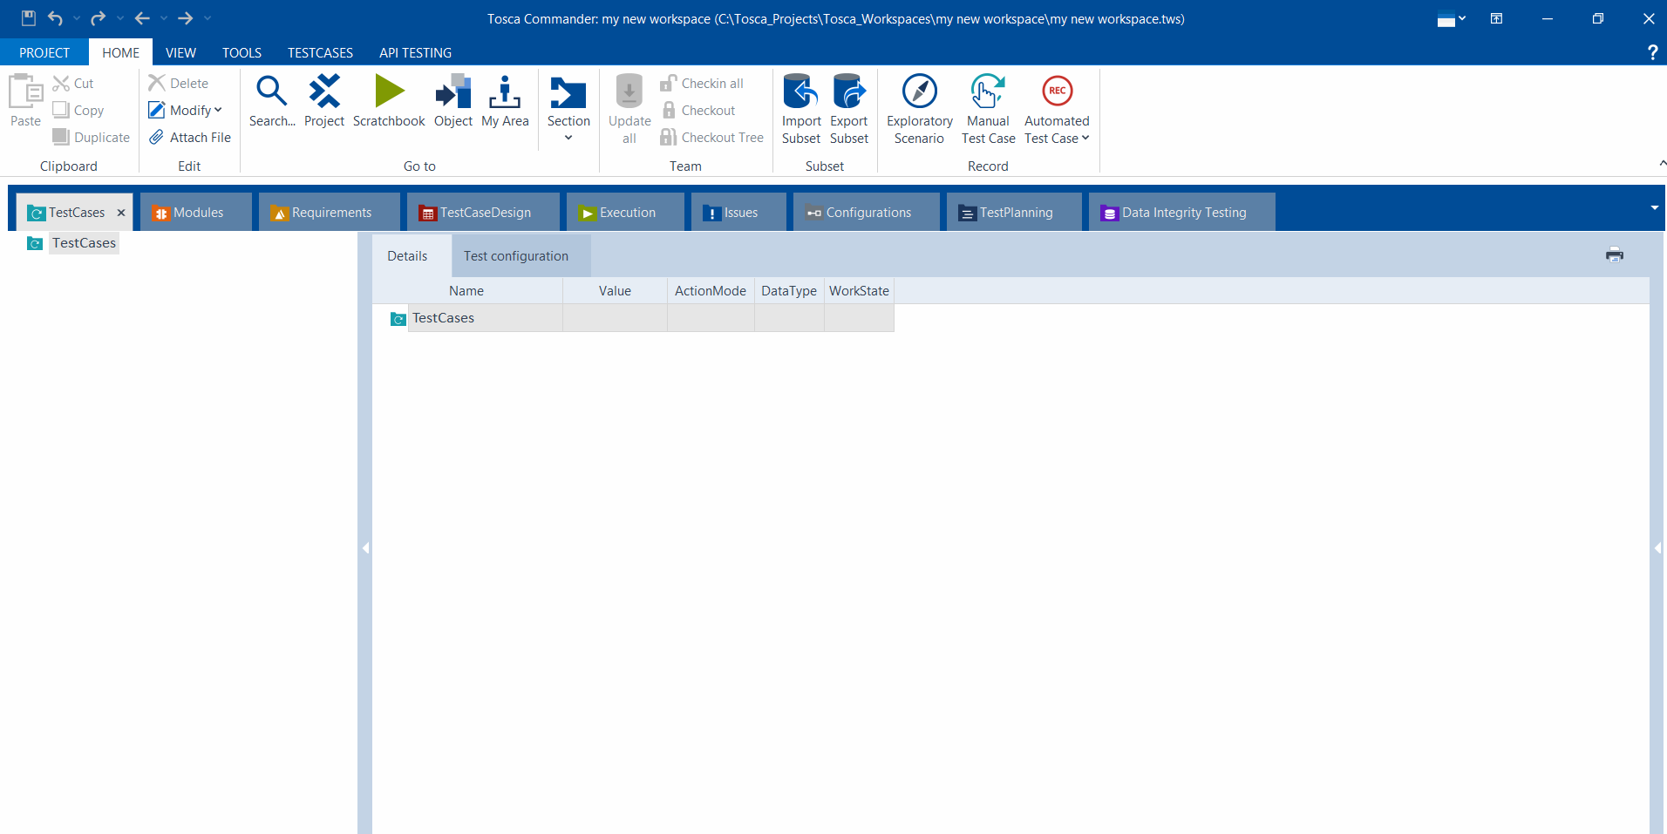

After creating workspace, you will get the login credentials page as the below.
Enter the login credentials.

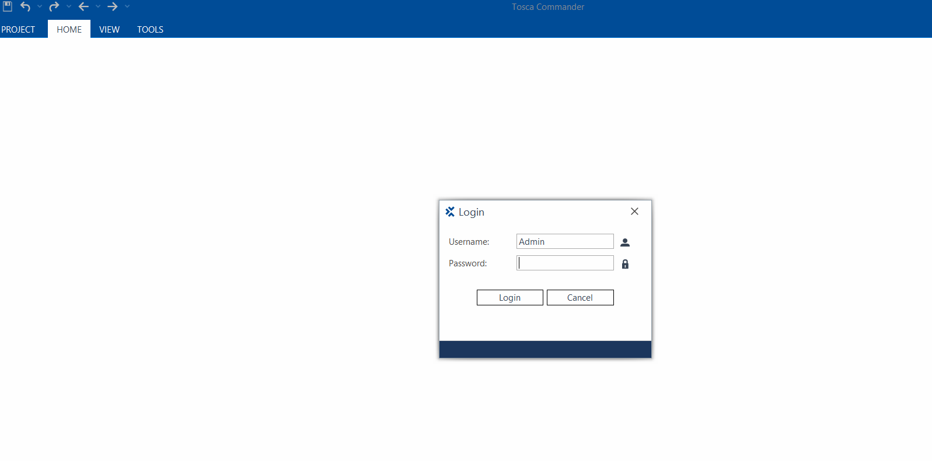

PLAN CREATE AND EXECUTE TESTS-
- Tricentis Tosca helps you to plan, create, and execute your test cases in a straight-forward and reusable manner to minimize your maintenance efforts and achieve sustainable automation.
- Tricentis Tosca is made up of different sections that variously help you in the planning, creation, and execution of your test cases.

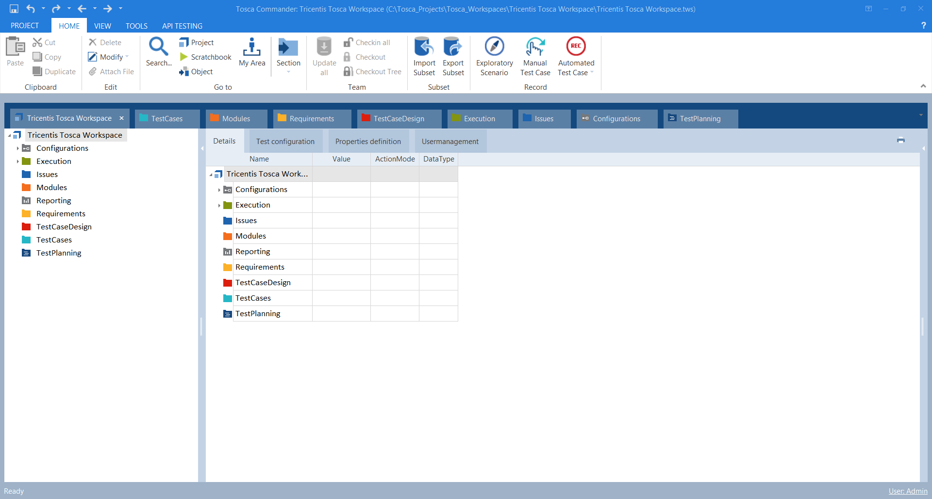

Tricentis Tosca sections-

- The Configurations section allows you to structure your test configuration parameters at one specific point in your repository.
- The Execution section, or green section, is where the actual test execution is performed. In this section, you can see the logs and results of your tests. You can also conduct exploratory testing or boost your performance with distributed execution in this section.
- The Issues section allows you to manage any undesired behaviour of the system under test. You can either create new issues that come up during test execution, or link existing issues to a Testcases log.
- The Modules section, or orange section, allows you to create modules for use in Testcases. These modules contain technical information that is used to steer test objects.
- The Reporting AddIn allows you to create reports to document the status of your project.
- The Requirements section, or yellow section, allows you to specify requirements for your Testcases as well as to assign risk coverage for efficient testing.
- The Testcases-Design section, or red section, enables you to put your test cases into a logical structure. In this section, you can create a Test Sheet to show all possible combinations of Testcases required to ensure full test coverage.
- The Testcases section, or blue section, is where you create your Testcases, which are made up of a series of Test Steps.
- The Test Planning section allows you to plan software quality assurance activities across the application lifecycle.
- Test Data Management allows you to manage, use, and reuse your test data.

MODULES IN TRICENTIS TOSCA-
Modules in Tosca are reusable objects that store UI elements, API endpoints, or system interactions. These modules act as the foundation for test case creation by defining the elements that Tosca interacts with during automation.
TYPES OF MODULES IN TOSCA-
- Standard Modules – Predefined modules for Excel, SAP, API, UI testing, etc.
- Custom Modules – Created by scanning applications using Tosca Xsan.
- Reusable Modules – Modularized test steps for reusability across test cases.
How to Create a Module in Tosca?
Step1- Open Tosca Commander
- Launch Tosca Commander
- Navigate to the Modules section
Step2- Scan the Application Using Xsan
- Right-click on Modules → Select Scan Application
- Choose Tosca Xsan
- Tosca will highlight the elements of the application
Step3- Identify & Save UI Elements
- Select the UI elements (buttons, text fields, dropdowns, etc.)
- Click Finish to save the scanned module
Step4- Use the Module in Test Cases
- Drag the module into a test case
- Map test steps to module attributes (e.g., input values, button clicks)
BENEFITS OF TOSCA MODULES-
✔ Reusability – Modules can be reused across multiple test cases.
✔ Maintenance-Friendly – Updating a module updates all related test cases.
✔ Scalability – Supports data-driven testing for multiple test scenarios.

CHECK-IN & CHECK-OUT IN TRICENTIS TOSCA-
Tosca allows multiple users to collaborate on test cases by using a Check-In & Check-Out mechanism. This feature is useful when working with shared repositories like Tosca Test Repository (TTA), Tosca Server, or SQL Database.
- What is Check-In & Check-Out?
Check-Out: Locks a test case, module, or object for editing so no other user can modify it.
Check-In: Saves the changes to the shared repository and unlocks the object for others to use.
How to Check Out an Object
- Right-click on the object (Testcase, Module, Execution List, etc.).
- Select "Check Out" (or "Check Out Tree" if you want to check out all child objects).
- The object status changes to Checked Out (green pencil icon), meaning you can now modify it.
How to Check in an Object
- Right-click on the checked-out object.
- Select "Check In" (or "Check In All" for multiple objects).
- Tosca saves your changes and updates the repository.
- The object's status changes back to Checked In (normal state, no pencil icon).
CHECK OUT TREE IN TRICENTIS TOSCA-
The Check Out Tree feature in Tricentis Tosca allows you to check out an object along with all its dependent or child objects. This is useful when you need to modify multiple related elements together, ensuring consistency in your changes.
How to Use Check Out Tree in Tosca?
- Right-click on the object (Testcase, Module, Execution List, etc.).
- Select "Check Out Tree" from the context menu.
- Tosca will automatically check out the selected object and all its child elements
UPDATE ALL IN TOSCA
The "Update All" feature in Tricentis Tosca is used to update all modified and checked-out objects in your workspace. This ensures that you have the latest changes from the central repository and that your modifications are properly synchronized.

How to Use "Update All" in Tosca?
- Open Tosca Commander.
- Go to the "Project" tab in the menu.
- Click on "Update All" (or right-click on the root project and select "Update All").
- Tosca will update all modified objects by fetching the latest versions from the repository.
IDENTIFYING ELEMENTS IN TOSCA-
In Tosca Xsan, you can identify controls in your test application by using multiple identification methods. The identification of controls by their properties is the default identification method in Tosca Xsan. However, if your controls cannot be identified uniquely by their controls, there are additional ways to identify controls.
You can identify controls in the following ways:
- Identify controls by properties
- ID, NAME ETC….
- Identify controls via anchor
- Identifying elements with the help of other unique elements.
- Identify controls by index
- Uniquely identify multiple buttons, dropdowns, or text fields.
- Identify controls via an image
- Elements are difficult to identify with standard object recognition.
WORK STATE (TEST CASE)-
In Tosca (Tricentis Tosca), a Work state refers to the status or stage of an object (such as Testcases, Test Steps, Modules, Execution Lists, etc.) within the workspace. Work states help track changes, approvals, and versioning of test artifacts in Tosca.
EX:
Planned
IN Work
Completed

ACTION MODE (TEST CASE)-
In Tricentis Tosca, Action Mode defines how a test step interacts with an object during test execution. It determines what Tosca does with the test object (e.g., enter a value, verify a value, select an option, etc…

TYPES OF ACTION MODE IN TOSCA-
- Input – Enters the specified value into a field (e.g., text box, dropdown).
- Select – Selects a specific value from a dropdown or list.
- Verify – Checks if the object’s actual value matches the expected value.
- Buffer – Stores the value of an object in a buffer for later use.
- WaitOn – Waits until the object becomes available or a condition is met.
- Constraint – Uses conditions to limit search results in table-based or dynamic elements.
- Exists – Checks whether an object is present or not.
BUFFERS-
In Tricentis Tosca, a buffer is a temporary storage location for values that can be used again. Buffers can be used to store static or dynamic values.
Buffer Operations
The folder TBox Automation Tools->Buffer Operations in the Standard subset contains the following Modules:
- TBox Set Buffer
- TBox Name To Buffer
- TBox Partial Buffer
- TBox Delete Buffer

TBOX SET BUFFER-
Use the Module TBox Set Buffer to perform one of the following actions:
- Create a Buffer with a particular value.
- Verify the value of an existing Buffer.
ModuleAttribute | Description
<Buffername> | Replace <Buffername> with the name of the Buffer.  - To save a value to the Buffer, enter the desired value into the Value column. Use ActionMode Input.  - To verify the value of the Buffer, enter the value in question into the Value column. Use ActionMode Verify.
The Module has the following ModuleAttribute:

This example shows how to work with TBox Set Buffer

- The first TestStep saves the value 12345 to a Buffer named ExampleBuffer.

- The second TestStep checks whether the value of the Buffer named ExampleBuffer is 12345.

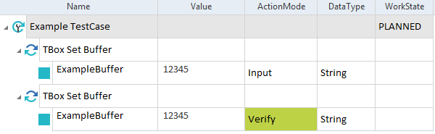

TBOX NAME TO BUFFER-
- This Module allows you to buffer the name of the Testcases that uses the Module.
The Module TBox Name To Buffer has the following ModuleAttribute:
ModuleAttribute | Description
Buffer | Name of the buffer to which you want to save the TestCase.  Use ActionMode Input.

In this example, you write the name of the TestCase TestCase 12345 to a Buffer named TC_Name.
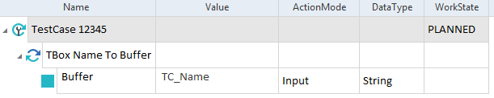

TBOX DELETE BUFFER-
To delete an existing buffer perform the following steps:
- Select the buffer entry you want to delete in the Buffer Viewer.
To select multiple buffers, hold the CTRL key.
- Hit the Delete key to delete the selected buffers.
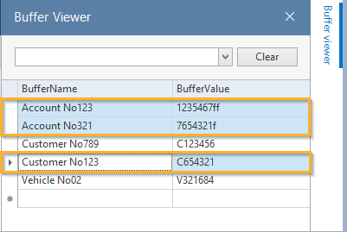

Key Concepts of Buffers in Tosca
- Creating Buffers
  - Buffers are created using the Set Buffer option in Tosca.
  - Syntax: {B[BufferName]}
  - Example: Set Buffer OrderID = 12345
- Using Buffers

How do I buffer a value?
To buffer a value from a test object, you'll need to do two things:
- A Buffer name must be specified as a value of the control to be steered.
- Buffer is selected as the ActionMode.
Static Buffer :
Set some static value
Dynamic Buffering

What is an XBuffer?
A dynamic value is mostly embedded into a static string. The XBuffer enables the verification of this kind of dynamic value with the following syntax.

Syntax: | {XB[<BufferName>]}
The result of this verification is both the buffer value and what the verification produces. This functionality is especially practical in the context of license and contract numbers or other values produced at runtime.

- Modifying Buffers
  - Buffers can be updated or overwritten with new values at any step.
- Clearing Buffers
  - Use the Delete Buffer

Use Cases of Buffers in Tosca
- Storing and retrieving user credentials dynamically.
- Saving transaction IDs, order numbers, or invoice numbers.
- Using calculated values for further validation or input.
- Passing values between different test cases in reusable modules.

TABLE STEERING-
Table Steering is a method in TOSCA that enables automated test scripts to dynamically interact with tables by identifying rows and columns based on unique identifiers, indexes, or specific conditions. It helps in verifying table content, selecting specific rows, and performing actions like clicking buttons within table cells.

Types of Table Steering in TOSCA
- Static Table Steering
  - Used for tables with a fixed structure (consistent number of rows and columns).
  - Rows and columns can be accessed using absolute positions (e.g., Row 2, Column 3).
- Dynamic Table Steering
  - Used for tables where data changes dynamically (e.g., user lists, transaction records).
  - Identifies rows based on specific conditions (e.g., a row containing a particular value).
Steps to Perform Table Steering in TOSCA

1. Identify the Table
- Scan the application using TOSCA XScan.
- Ensure that TOSCA correctly recognizes the table structure.

2. Define Row Conditions (Dynamic Row Selection)
- Use "Search for Row By Value" to find a row containing a specific value.
- Example: Locate a row where the column "Status" has the value "Approved".

3. Interact with Table Cells
- Perform actions like clicking buttons, entering data, or validating values inside the table.
- Use column names or indexes to specify where to interact.

4. Verify Table Data
- Use verification steps to check table content (e.g., validate if a certain value exists in a row).
Example: Automating a Web Table in TOSCA
Scenario: Click the "Edit" button for a user with the name "John Doe" in a table.

Step-by-Step Approach
- Identify the table using XScan.
- Use Search for Row By Value → Find the row where the "Name" column = "John Doe".
- Perform an action → Click the "Edit" button in that row.

TOSCA Table Steering Representation
Action | Column Name | Value
Search for Row By Value | Name | John Doe
Click | Edit Button | (Current Row)

DYNAMIC EXPRESSIONS-
Tosca TBox allows date and time expressions to be dynamically generated. You can use various dynamic expressions which can be combined according to a specific syntax.
Tosca TBox provides on-screen descriptions for dynamic values, including date and time expressions.

Using current date and time values-
Expression | Description | Example
{DATE} | Full date | 30.12.2015
{TIME} | Current time | 15:09
{DATETIME} | Current time stamp | 20151230150914
{DAY} | Current day | 30
{MONTH} | Current month | 12
{YEAR} | Current year (two-digit) | 15
{MONTHFIRST} | First day of the current month as a complete date | 01.12.2015
{MONTHLAST} | Last day of the current month as a complete date | 31.12.2015
{QUARTERFIRST} | First day of the current quarter as a complete date | 01.10.2015
{TRIMESTERFIRST} | First day of the current trimester as a complete date | 01.09.2015
{HYEARFIRST} | First day of the current half year as a complete date | 01.07.2015
The following dynamic expressions use the current date and time as base values.

Formats for the expressions DAY, MONTH, YEAR or DATE can be altered with a prefix.
Prefix | Description | Example
{LDATE},{LDAY},{LMONTH},{LYEAR} | Date, day, month or year, according to the system settings that are currently valid | {LDATE} = Monday, December 30, 2015  {LDAY} = Monday  {LMONTH} = December  {LYEAR} = 15
{NDAY},{NMONTH},{NYEAR} | Day, month and year are always entered in double figures. Single digit results are returned with a leading zero digit. | {NDAY} = 30  {NMONTH} = 12  {NYEAR} = 15
{ADAY},{AMONTH} | Returns the first three characters of a day or month. | {ADAY} = Mon  {AMONTH} = Dec

Calculating dates from the base date
Dates can be calculated starting from the base date. As a result, Offsets will either be added or deducted. The following table contains all the possible values. Please take care of notations and make sure not to use any spaces.
Unit | Description
d | days
w | workdays; this includes all weekdays except for Saturdays, Sundays, and user-defined holidays
M | months
y | years
h | hour as a number from 1 to 12
H | hour as a number from 0 to 23
m | minutes
s | seconds
fff | milliseconds

Random Regex:

{RANDOMREGEX["<Regular expression>"]}

{RANDOMREGEX["^[A-Z][a-z]+[0-9]{4}$"]}
A value starting with a capital letter from A-Z is generated, followed by any number of lower case letters and exactly four digits between 0-9. The ^ character denotes the beginning of the line, and the $ character the end of the line.
The generated expression is for instance: Ecqwp1989.

Regular Expression:
{REGEX[{B[B_12345]} "(iteration [0-9]{4})"]}
This expression can for instance be used to verify the following string: E610Overviewprocess (iteration 0012). In this example, it is assumed that the value E610Overviewprocess was written to the buffer B_12345 beforehand.

In the application, the label shows a word as welcome message and the username, followed by an exclamation point. A few possible examples are:
- hello sarah85!
- welcome peter!
- bonjour user1234!
The expression in userinfo verifies if the text in this label matches the pattern and stores the username to the username buffer:
{Regex["[a-z]* (?<username>[a-z|\d]*)!"]}
The pattern includes:
- [a-z]*: expression for a string of any length followed by a whitespace
- <username>: name for the buffer
- [a-z|\d]*: subexpression which identifies a string of any length which contains characters or numbers
- !: expression that matches an exclamation point.
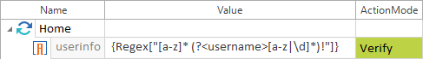

DATE SYNTAX -
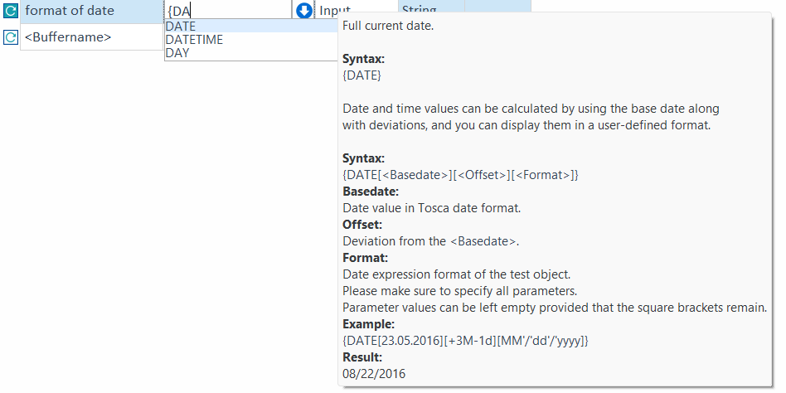

REGEX SYNTAX-
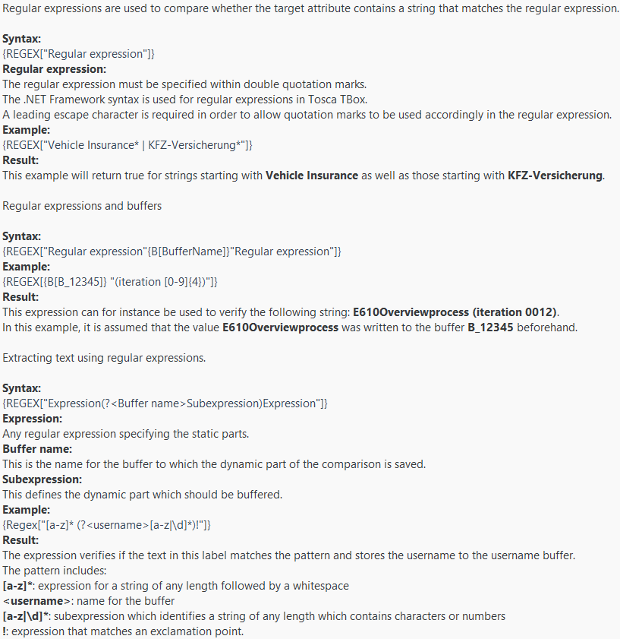

CONDITION STATEMENTS-
Conditional statements and loops can be created via the context menu of Testcases or Test Step folders or via the option Create Object in the dynamic menu Testcases:
- IF Statement
- DO Statement
- WHILE Statement
A Conditions object is created for all three options. In this folder you define the condition that must be fulfilled so that the next step can be taken. The next step depends on the type of the statement.

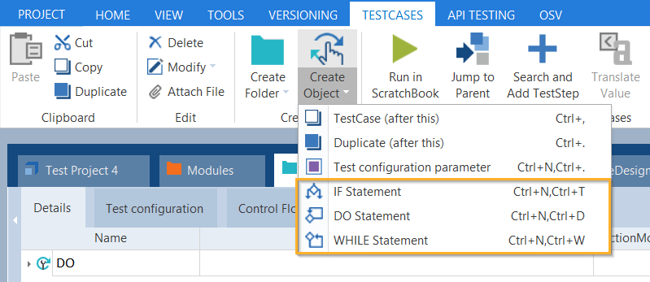
Statement options

Creating IF-THEN statements
When you create IF statements, Tosca will automatically create a THEN statement along with the Conditions object. You can also create an ELSE statement via the context menu of IF statements if required, or by left-clicking the IF statement and selecting Create Object->ELSE Statement from the dynamic menu TestCases.
If the condition is fulfilled, the TestSteps are executed once in the THEN statement. If the condition is not fulfilled however, the TestSteps are run once in the ELSE statement.
Order of conditions:
- IF
- Condition (within the IF statement)
- THEN (within the IF statement)
- ELSE (optional)

Creating DO statements
- When you create DO statements, Tosca will automatically create a Loop object along with the Conditions object.
- TestSteps within the Loop object are run repeatedly until the condition is no longer fulfilled. The result of the last repetition is thus negative.
- DO statements contain the property MaximumRepetitions in order to avoid infinite loops. The Value column shows the maximum number of attempts for a TestStep to be run. The default value is set to 30.

Order of conditions:
- DO
- Loop (within the DO statement)
- Condition (within the DO statement)

Creating WHILE statements
When you create WHILE statements, Tosca will automatically create a Loop object along with the Conditions object.
If the condition is fulfilled, TestSteps within the Loop object are run repeatedly until the condition is no longer fulfilled. The result of the last repetition is thus negative.
WHILE statements contain the property MaximumRepetitions in order to avoid infinite loops. The Value column shows the maximum number of attempts for a TestStep to be run. The default value is set to 30 (see "MaximumRepetitions property").
Order of conditions:
- WHILE
- Condition (within the WHILE statement)
- Loop (within the WHILE statement)

LIBRARY-

